Bid Processing in Purchasing

The Create/Modify Bid page is used to create new bids and edit existing bids. The bids are submitted to vendors to solicit a quote on specific products. Requisitions with a credit card code cannot be added to a bid.
You can only view your created bids. However, if the Global Access field is selected on the District Administration > Maintenance > User Profiles > Purchasing Permissions tab in District Administration, you can view bids created by all users. Only the final approver in a selected workflow can create or modify a bid.
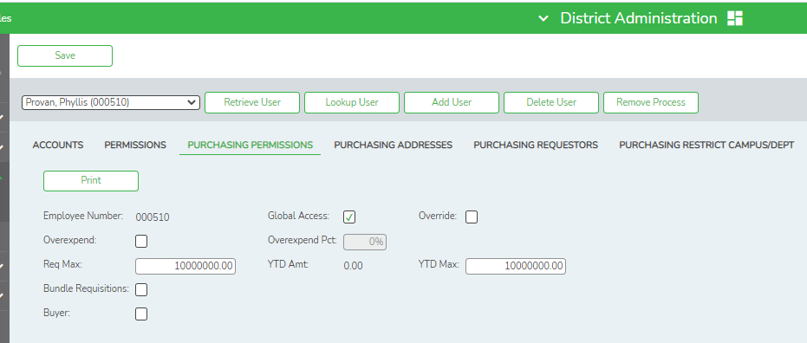
You will need to set up the Vendor Bid information in Finance.
Finance > Maintenance > Vendor Information > Vendor Name/address tab
By default, the Bid Eligible field is selected. Deselect the field if you wish to clear it.
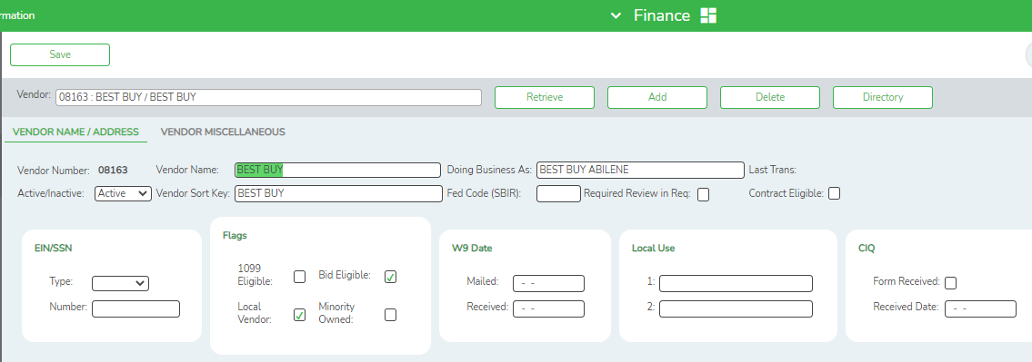
To set up the Bid Number go to:
District Administration > Options > Purchasing/Warehouse Options
Under Bid Information:
● The Auto Assign Bid Number field is selected by default allowing the next bid number to be automatically assigned when using the bid processing feature in Purchasing. The option cannot be modified.
● Click Next Available Bid Number to select the next available bid number to be assigned in the Next Available Bid Number field, or type a number to find the next available number.
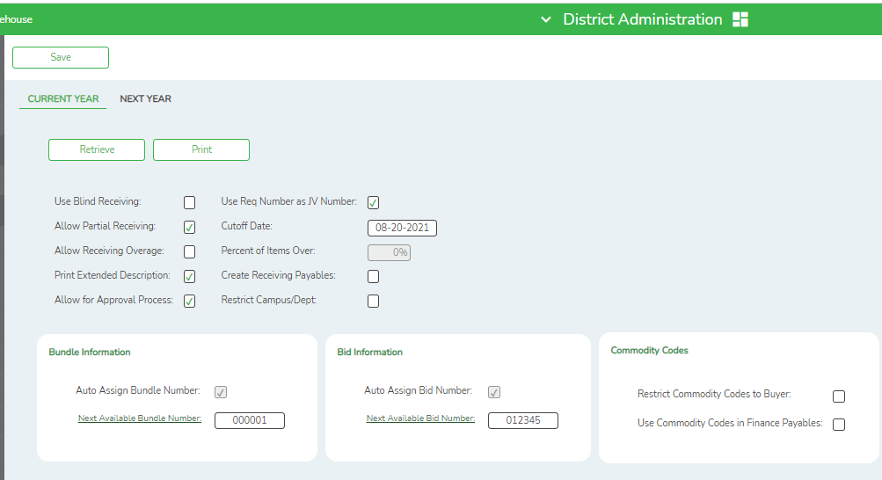

To Create a new bid from existing requisition bid line items, or modify and existing bid.
Purchasing > Maintenance> Bid Processing > Create/Modify Bid
To create a bid, click Add Bid.
1. Under Bid Information:
● The Bid Nbr field displays AUTO indicating that the Auto Assign Bid Number field is selected on the Options > Purchasing Options > Current Year tab in District Administration. The bid number is automatically populated with the next available bid number when the bid is saved.
● The Buyer field displays the logged on user's name.
● In the Payment Terms field, type the allowed payoff period (e.g., Net 30).
● In the Request Date field, type the date you are requesting the bid in the MMDDYYY format. Or, select a date from the calendar.
● In the Date Open field, type the beginning date for the bid in the MMDDYYYY format. Or, select a date from the calendar. In the blank field, type the begin time in the HH MM format.
● In the Date Close field, type the ending date for the bid in the MMDDYYYY format. Or, select a date from the calendar. In the blank field, type the begin time in the HH MM format.
● In the Ship To field, press the SPACEBAR to view and select a shipping address from the drop-down list. The shipping addresses are populated from the Tables > Receiving Addresses page in District Administration.
● Click Distribute Ship To to replace the Ship To field for each individual bid item with the selected Distribute Ship To address.
- In the Freight Term field, press the SPACEBAR to view and select a freight term from the drop-down list. The freight terms are populated from the District Administration > Tables > Freight Terms page.
● In the Reference field, type the bid description.
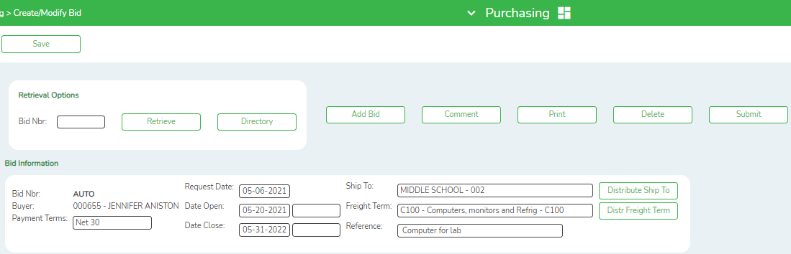
2.. Click Requisition Directory to select a requisition to be added to the bid. The Requisition Directory is displayed. Only requisitions pending final approval from the logged on user are displayed.
● To search for a specific item, type data in the desired search fields.
● To search through all available data, leave all fields blank.
● Click Search. A list of data that matches the search criteria is displayed.
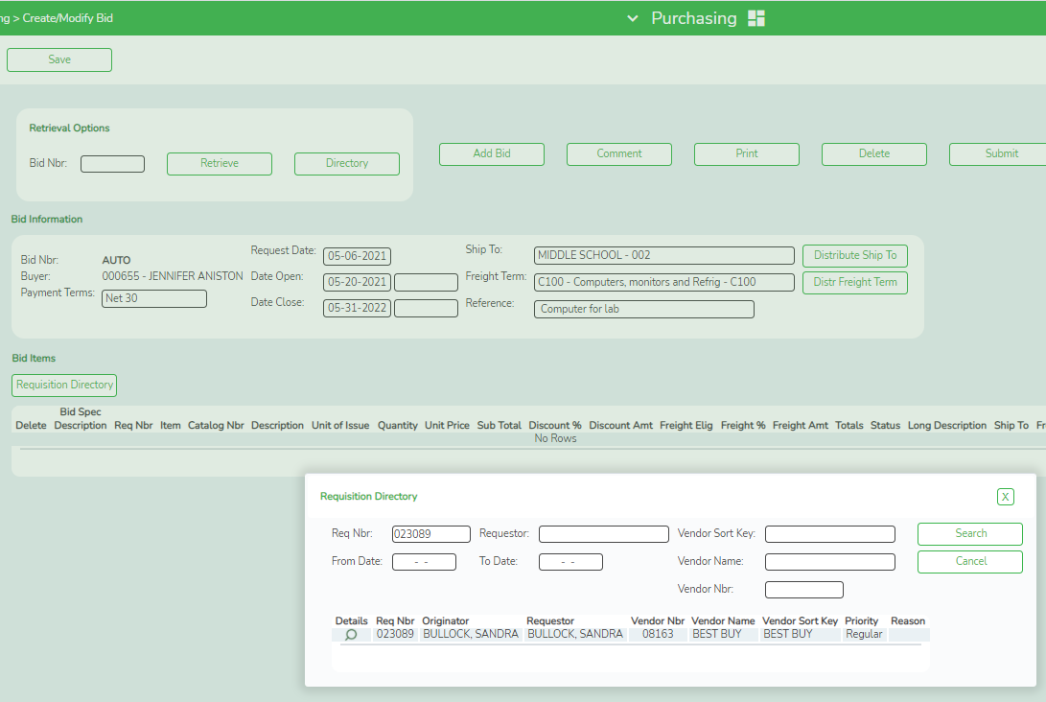

● Click to view the line items for the selected requisition.

● Click Copy Line Items to copy the line items from the requisition to the bid.
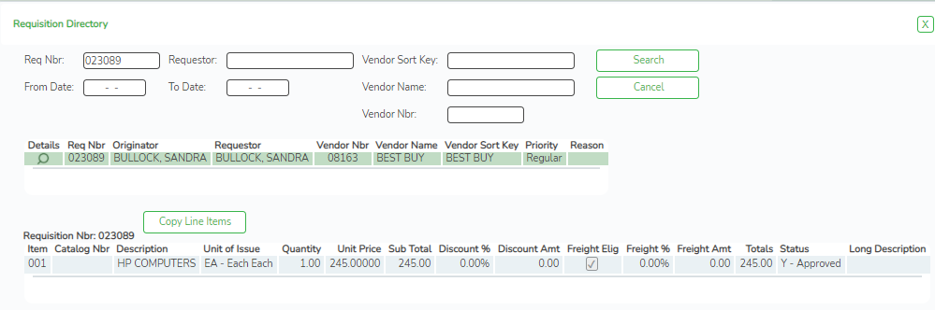

● Click Cancel or X to close the Requisition Directory.

3. Under Bid Items, the requisition line item details are displayed.
● Click Note to view or add bid notes. If notes exist, a paperclip icon is displayed on the Note button.
- Click Save. The bid status is changed to N - Saved, and the status for all pending requisitions in the bid is changed to Q - Bid for Quote. Requisitions can be viewed on the Purchasing > Inquiry > Requisition Status Inquiry page, but cannot be retrieved or approved on the Purchasing > Maintenance > Approve Requisition page.
❏ Click Submit. The bid is transferred to the Request Vendor Quote page.
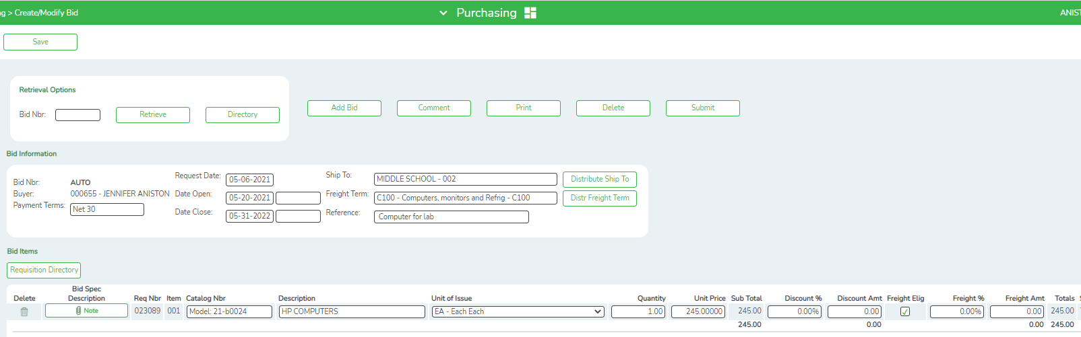
● Click to delete a requisition from the bid. The requisition line items are highlighted red to indicate that they will be deleted upon save.
NOTE: A trashcan icon is displayed for each requisition. You cannot delete a single line item, unless it is the only line item in the requisition.
4. Click Comment to view or add comments to the bid. The comments are strictly for bid purposes, and are not displayed on the purchase order. If comments exist, a paperclip icon is displayed on the Comment button. Click OK
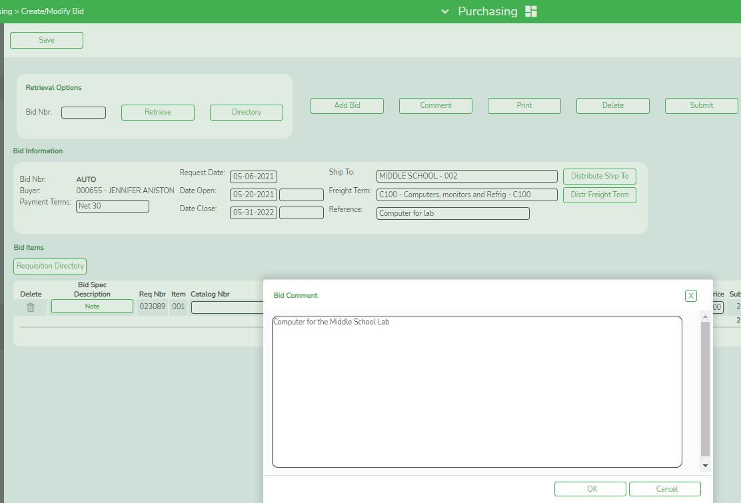
5. Click Print to print the bid details on the page. The report can be viewed and saved in various file formats.
Click to save and print the report in PDF format.
Click to save and print the report in CSV format. (This option is not available for all reports.) When a report is exported to the CSV format, the report headers may not be included.
Click X to close the report window. Some reports may have a Close Report, Exit, or Cancel button instead.
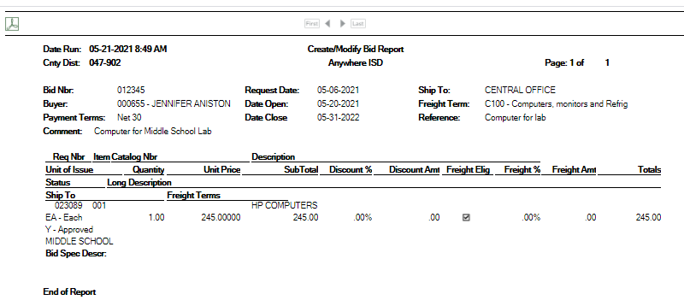
6. Click Delete to delete a bid. All associated requisitions are updated with a P - Pending status. Requisitions can be viewed on the Purchasing > Inquiry > Requisition Status Inquiry page, and approved on the Purchasing > Maintenance > Approve Requisition page.
7. Click Save. The bid status is changed to N - Saved, and the status for all pending requisitions in the bid is changed to Q - Bid for Quote. Requisitions can be viewed on the Requisition Status Inquiry.
Purchasing > Inquiry > Requisition Status Inquiry
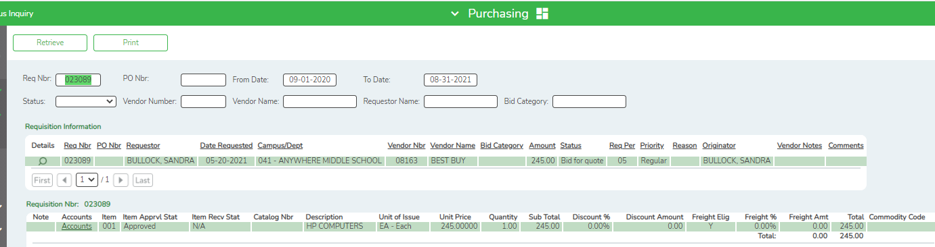
The requisitions cannot be retrieved or approved on the Purchasing > Maintenance > Approve Requisition page.
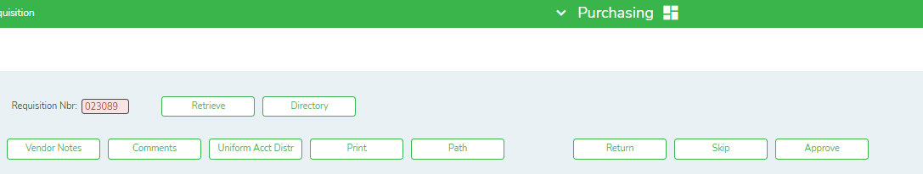
Shown at the bottom of the Screen
Shown at the bottom of the page

8. Click Submit to submit the bid to the Request Vendor Quote page.
You are able to select vendors to be solicited with a request for quotation (RFQ) for specific products.
Purchasing > Maintenance > Bid Processing > Request Vendor Quote
The Request Vendor Quote page is used to submit a bid to a vendor to solicit a quote.
You can only view your created bids. However, if the Global Access field is selected on the Maintenance > User Profiles > Purchasing Permissions tab in District Administration, you can view bids created by all users
To Request a Vendor Quote:
1. Under Retrieval Options, in the Bid Nbr field, type a bid number and click Retrieve. The field can be a maximum of six digits. Leading zeros are not required.
If the bid number is not known, click Directory.
● To search for a specific item, type data in the desired search fields.
● To search through all available data, leave all fields blank.
● Click Search. A list of data that matches the search criteria is displayed.
● Select an item from the list. Otherwise, click Cancel.
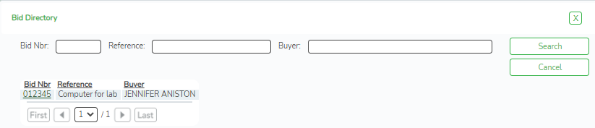
2. The Retrieve button is used to retrieve information from the last save. If you click Retrieve, any unsaved changes will be lost.
3. Under Bid Information:
● The Bid Nbr field displays the assigned bid number.
● The Buyer field displays the logged on user's name.
● In the Payment Terms field, type the allowed payoff period (e.g., Net 30).
● In the Request Date field, type the date you are requesting the bid in the MMDDYYYY format. Or, select a date from the calendar.
● In the Date Open field, type the beginning date for the bid in the MMDDYYYY format. Or, select a date from the calendar. In the blank field, type the begin time in the HH MM format.
● In the Date Close field, type the ending date for the bid in the MMDDYYYY format. Or, select a date from the calendar. In the blank field, type the begin time in the HH MM format.
● The Ship To field displays the selected shipping address for the bid.
● The Reference field displays the bid description.
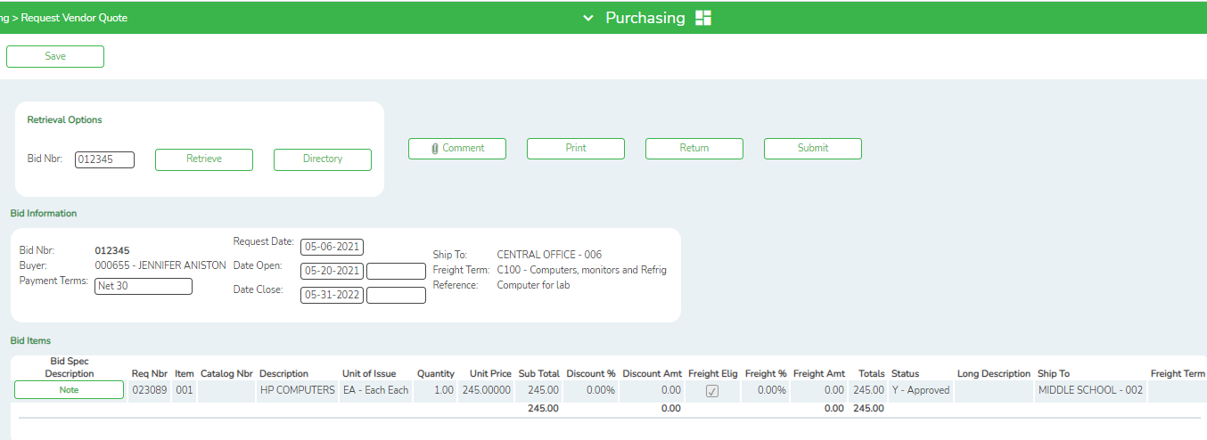
4. Under Bid Items, the requisition line item details are displayed and cannot be modified.
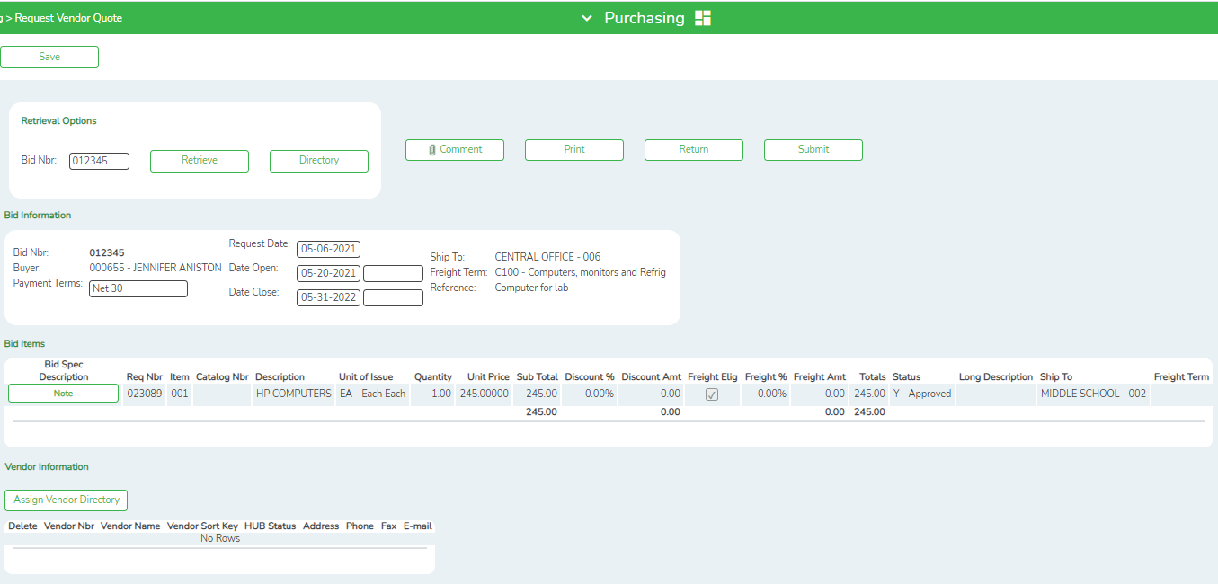
5. Only vendors with the Bid Eligible field selected on the Vendor Name/Address tab are displayed.
Finance > Maintenance > Vendor Information > Vendor Name/Address
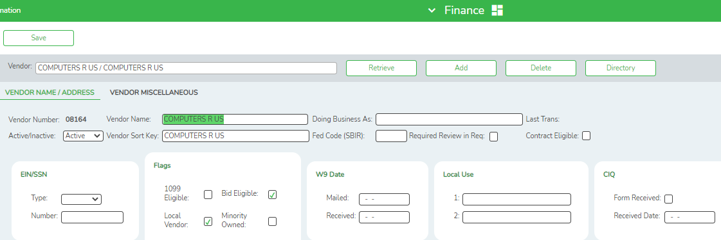

6. Click Assign Vendor Directory to select the vendors to be solicited. The Assign Vendor Directory is displayed.
Purchasing > Maintenance > Bid Processing > Request Vendor Quote
● To search for a specific item, type data in the desired search fields.
● To search through all available data, leave all fields blank.
● Click Search. A list of data that matches the search criteria is displayed.
● Select the vendor(s) that you want to solicit and click OK. The selected vendors are displayed under Vendor Information.
● Click Cancel to close the directory.
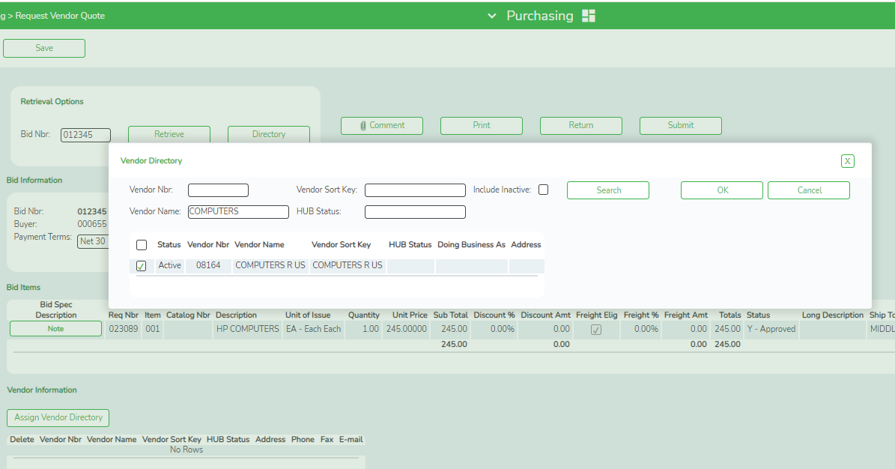
7. Click Comment to view or add bid comments. The comments are strictly for bid purposes, and are not displayed on the purchase order. If comments exist, a paperclip icon is displayed on the Comment button.
8. Click Print to print the bid details on the page.
9. Click Return to return the bid to the Create/Modify Bid page.
10. Click Save to save the vendor quote request. The bid status is changed to Q - Saved.
11. Click Submit to submit all of the bid line items to each selected vendor. The bid is transferred to the Vendor Response page.
